

MAC FILTERING

NOTE: YOU CAN ONLY FILTER UP TO 20 MAC ADDRESSES. THIS IS THE LIMIT.

When setting up MAC filtering. You have to pay attention to the interface setup screen. Make sure that you set the correct interface to remote. For example, the unit that is attached to the PC we will refer to as ‘local’. It is locally attached to the ethernet. In addition, we will set up the wireless side of the device to remote.

This is an example, you can set the remote and local settings however you wish to set them. However, you must remember which interface you designated as local and which one you designate as remote.
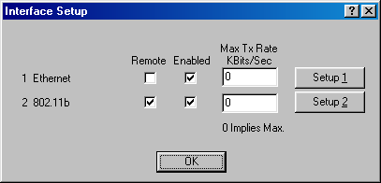

Scenario 1: You are an ISP that desires to only allow specific PCs to communicate with the wireless network. Your local network in this case is at the customer’s premisis.

LOCAL
REMOTE

Diagram 1
This is the unit we are configuring.

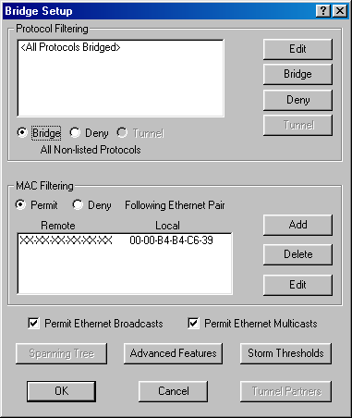

In this case, you are permitting only one computer with the MAC address of
00-00-B4-B4-C6-39 to communicate out to the wireless network. You are also permitting everyone XX-XX-XX-XX-XX-XX in from the wireless network to communicate with you.

Scenario 2: You are a company that desires to keep everyone off of your wireless network, everyone except a remote location that you know the MAC addresses of their PCs. Notice the ‘local’ and ‘remote’ settings have changed.

LOCAL
REMOTE

This is the unit we are configuring.
MAC: 00-00-a2-d3-c6-ff

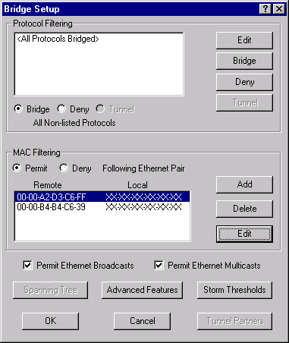

In this case, you are permitting both the computer with the MAC address of
00-00-B4-B4-C6-39 and the wireless device with a MAC address of 00-00-a2-d3-c6-ff . You are also permitting everyone XX-XX-XX-XX-XX-XX locally to communicate to the wireless network.

